Name: ______________________________ Date:___________________
Hands-On Activity: Measuring Acidity By: Caitlyn Yackeren

EXTRA PRACTICE PROBLEMS

Directions: Given the following information about certain solutions, Solve for pH or [H₃O⁺¹]!

- Milk:
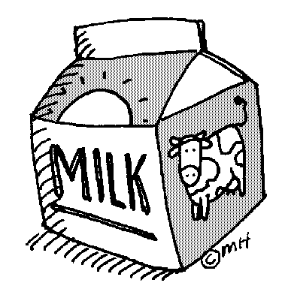

pH Level: ____8____

[H₃O⁺¹] : _________ _

Acid or Base?: ___________

- Mountain Dew:
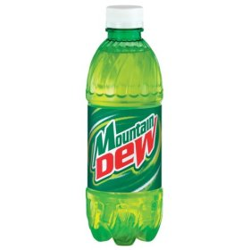
pH Level: ___________

[H₃O⁺¹] : ____10^-3.27___

Acid or Base?: ______________

- Pepsi:
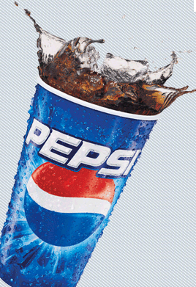
pH Level: __________

[H₃O⁺¹] : ____10^-2.61______

Acid or Base?: ___________

- Water:
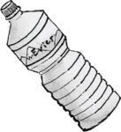

pH Level: ____7______

[H₃O⁺¹] : __________

Acid or Base?: ___________

